➢➢ Explanation :
- Get the dividend in the HL register pair. Get the divisor in the accumulator and store it in register C.
- Initialize quotient in register pair DE as 00 H.
- Perform the division by subtracting the divisor from the dividend, till the dividend is greater than the divisor. Increment the quotient every time the dividend is greater than the divisor when the subtraction is performed.
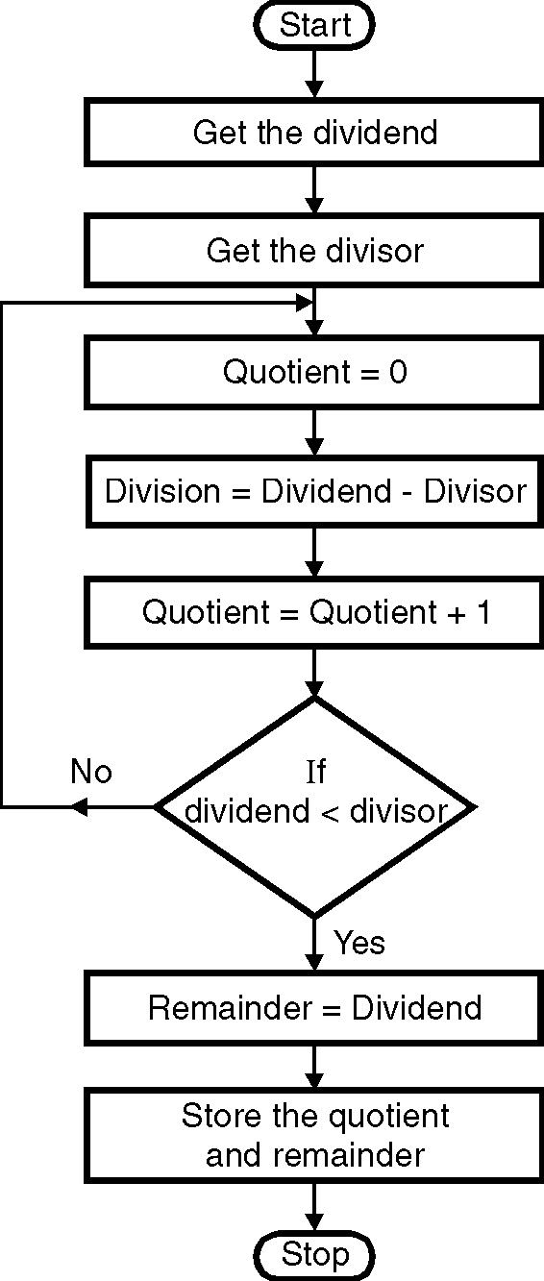
- When the dividend becomes less than the divisor then this dividend is the remainder. Store the quotient and remainder.
➢➢ Algorithm :
Step I : Get the dividend in the HL register pair.
Step II : Get the divisor in the accumulator
Step III : Initialize quotient =0
Step IV : Perform division,
Division = Dividend – Divisor
Step V : Increment quotient by 1
Step VI : Check if dividend < divisor,
if not zero goto step IV
Step VII : Remainder = Dividend
Step VIII : Store the quotient and remainder.
Step IX : Stop.
➢➢ Flowchart : Refer flowchart 21.
ØØ Program :
Instruction Comment
LHLD D000H ; Get the dividend
LDA D002H ; Get the divisor
MOV C, A ; Store the divisor in C
LXI D, 0000H ; Initialize Quotient = 0
BACK:MOV A, L ;
SUB C ; Division = Dividend – Divisor
MOV L, A
JNC SKIP
DCR H ; Subtract borrow of previous subtraction
SKIP: INX D ; quotient = quotient + 1 Flowchart 21
MOV A, H
CPI 00 ; Check if dividend < divisor
JNZ BACK
MOV A, L ; if no repeat
CMP C
JNC BACK
SHLD E002H ; Store the remainder
XCHG
SHLD E000H ; Store the quotient
HLT ; Terminate program execution

